  Parent-Student Handbook | Vision  We empower learners to be confident and innovative global citizens.  MISSION  Island View is an inclusive school community which cultivates engaged and resilient learners.  CODE OF CONDUCT  Be respectful, be responsible, be safe.

Contents
Principal’s Welcome Message 2
School Life 2
Hours of Instruction and Bell Schedule 2
Communication 3
Classroom Environment 3
SchoolCashOnline 4
Lunch & Snack 4
Recess and our School Playground 4
Toys and Electronic Devices 5
Transportation 5
Homework 6
Assessment 6
Extra-Curricular 6
Parent Involvement 7
Visitor Policy 7
Parent School Support Committee (PSSC) 7
Home and School 8
Class Participation 8
Parent Responsibilities 8
Positive Learning Environment 9
Behaviour Standards 9
Student Attendance 10
Medical Information 10

Principal’s Welcome Message
Welcome to Island View School. Island View School is located on the west side of Saint John at 496 Ridge Row and delivers English Prime and French Immersion curriculums Kindergarten to grade five to 370 students. Situated in a quiet subdivision just off Manawagonish Rd, Island View School overlooks South Bay of the Saint John River, and over the other side of the ridge sits the Bay of Fundy, home of the highest tides in the world. Island View School takes pride in presenting our students with learning opportunities connected to our community inside our school walls and beyond.
Our learning environment is supported by strong parent involvement. The Island View Home and School Committee plans many activities that foster the social emotional wellbeing of our students and provide opportunities for the community to interact with the school. Fundraising for school improvements, Christmas activities for the students, and Fun Day at the end of the year are just a few of the things that have become traditional events put on jointly by Island View and the Home and School. We also have an active Parent School Support Committee that helps guide decisions for our school. We welcome you to join our Home & School and/or Parent School Support Committee.
This handbook provides some of the details about our school that should help you become acquainted with our procedures.
Thank you,

Aimee Short
Principal
Aimee.Short@nbed.nb.ca
(506) 658-5346

School Life

Hours of Instruction and Bell Schedule
Bell Schedule | Student Activity
7:45 - 8:00 am | Student Drop-off |  | Being on time ensures your child is taking part in essential routines to set the groundwork for a positive learning environment.
8:05 am | Instruction begins
10:00 am | Morning Recess
10:15 am | Instructional time
12:20 pm | Lunch Recess
1:00 pm | Instructional time
2:15pm | Dismissal

Communication
At the beginning of each school year, families will receive a student information form for guardians to fill out and/or update. The contact information will be used by the school to reach you regarding concerns and/or emergencies. It is important to list any adults who have permission to pick up your child. Families may receive communication using the following platforms:
- Teacher – email, phone, homework folder, Microsoft Teams
- School – Weekly email message (School Messenger), phone, SchoolCashOnline
- District – email, BusPlanner
- Province (EECD) – email
If you have questions or concerns, we ask that parents/guardians contact their child’s teacher as the first line of communication. If problems are unresolved after speaking with the classroom teacher, please contact the Principal or Vice Principal through email or phone call.
School Closure Notice: In the event of a school closure (inclement weather, or otherwise), ASD-S sends notification through email, Twitter, website and local media. You can find our Education Centre using the Twitter handle @ASD_S or on their website home page at https://secure1.nbed.nb.ca/sites/ASD-S/Pages/welcome.aspx
On rare occasions, ASD-S will announce an early closure, and students will be dismissed at approximately 11:30am. In these situations, the school will verify there is an adult to receive the students when they arrive home, and that we have the correct information regarding the location they travel to in case of early dismissal. Email will be the first form of communication in this case, and phone calls will follow if we have not received confirmation from a parent/guardian. Provide the school with up-to-date contact information as things change throughout the year.
School Website: Our school website can be found at the following URL: http://web1.nbed.nb.ca/sites/district8/islandview/Pages/default.aspx
Please visit the school website for important links:
- Classroom supplies
- SchoolCashonline
- Teacher contact information
- Other helpful links

Classroom Environment
The classroom environment is a critical component for quality student learning. Our classrooms have agreed upon expectations for creating a quality learning space. Therefore, classroom and school expectations are taught at the beginning of the year and reinforced as needed. Here are more things you should know about our classrooms:
- Small group guided instruction is a component of all classrooms. Sometimes teachers may choose to pair with other classes throughout the building for multiage learning.
- Physical education is taught four-five times per week for 35 minutes by a Specialist Teacher in the gym and/or outside.
- Music education is taught two times per week for 35 minutes by a Specialist Teacher in the music room and/or classroom.
- Indoor sneakers are required.
- Sunscreen, deodorant, hand cream, and hand sanitizer used at school must be unscented. No aerosol sprays are permitted.
- An emergency change of clothes should stay at school.
- Label all clothing and personal items with your child’s name.

SchoolCashOnline
To minimize the amount of money that is being handled by families and staff, electronic payments can be made to the school through SchoolCashOnline. Parents can sign up by clicking on the link found on the main page of our school website or by searching “schoolcashonline’. You will often hear of this site referred to as ‘Cashless Schools’ (as is the Saint John custom to refer to what it ‘used to be’ ). Items that can be paid for through this online system are not limited to, but may include: Student fees, Hot lunch, Tickets for events, Fundraising.

Lunch & Snack
Please send a water bottle filled with water only for your child to drink throughout the day. We have bottle filling stations available. Practice opening packages and plastics to ensure your child can eat independently. Talk with your child about what’s in their lunch box so they understand what is for snack and what is for lunch. Student lunches are unable to be microwaved or refrigerated at school.
What do I send with my child for lunch & snack?
- Send: fruits, vegetables, crackers, cheese, sandwiches, soups, pasta, yogurt, hummus
- Do not send: nuts of any kind, sugary drinks/juices, multiple treats (candy, cake, cookies)
Hot Lunch: Island View School runs a hot lunch program and parents can purchase items through the SchoolCashOnline program which can be found on the school website. Hot lunch items change depending on availability and feasibility.

Recess and our School Playground
Our playground offers a playground structure, basketball court, large, paved area, and a grassy hill for students to play on. We share the space among 370 children and often use play zones to manage the student population.
- Sunscreen, deodorant, hand cream, and hand sanitizer used at school must be unscented. No aerosol sprays are permitted.
Winter Weather: the winter wind can have a significant impact on the temperature of our outdoor space. Students will have an indoor recess when the wind chill is -18 degrees Celsius or colder. The playground equipment closes for the season when the ground beneath freezes. Proper clothing for the weather must be worn as we go outside up to -18. If you send it, we will encourage your child to wear it.

Toys and Electronic Devices
Students do not bring their own toys or electronics to the school (including phones). A toy may be an exception on special days or ‘show and tell’. If there is a toy that you feel is needed to enhance the playground experience for the students, please bring it to the attention of your child’s teacher since we would be happy to explore this idea to see if it would be a worthwhile purchase for all students to enjoy.

Transportation
Bussing Students:
Students who live within 1.6 km of the school are responsible for their own school transportation. Students who live 1.6km+ are eligible for bus transportation. Families are responsible for setting up bus transportation using the ASDS Bus Planner Website. The school can not change your bus route or times. The bus driver can not add stops. Bus routes are managed through the Anglophone School District South Transportation Department.
- ASD-S site for looking up bus information: https://asdsbp.nbed.nb.ca/
- Request for Transportation to an Alternate Address is found on the website
Our school has small, and very busy, drop off area. If your child is eligible for busing, we highly encourage you use it.
Student Drop-Off:
Drop your child off between 7:45am-8:00am. Staff are on duty during this time and students begin lining up at 7:55am to go inside. There is no outside supervision before 7:45am or after 8:00am

When dropping off your child in the drop off lane, drive around the back of the school in the left-hand lane. Pull up to the yield sign to drop off your child. This allows up to 5-6 cars to drop children off at once. Children should exit the vehicle on the left side. Cars may slowly pass in the right lane after dropping children off. Please be patient when using the drop off lane. If your child is eligible for bussing, we highly encourage using it to alleviate traffic congestion in the morning.

Students in grade 3-5 may be dropped off at the top of the hill to walk down the exit, on the sidewalk, to access the school grounds.

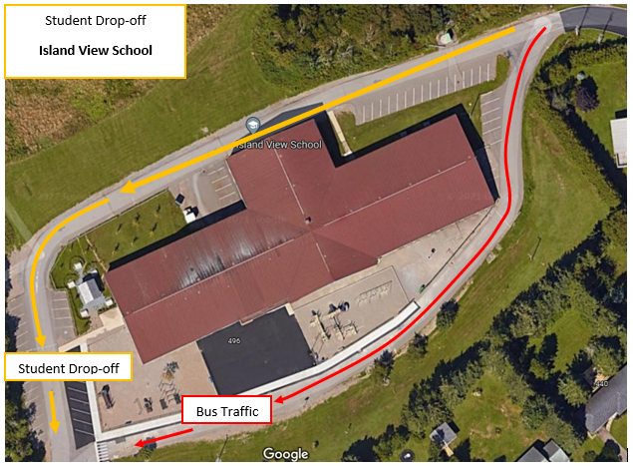

No cars may drive around the front of the building during school hours.

Homework
Homework is used to reinforce a concept already taught in the classroom, or to prepare for an upcoming lesson. Homework is not intended to be an uncomfortable and lengthy process each day, and if it becomes something that is a significant challenge for your child to complete, this could be indicative of a gap in learning. In these situations, please reach out to your teacher to discuss alternatives and to ensure the homework process remains an effective step for reinforcing learning.

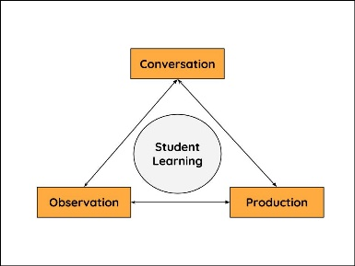
Assessment
Students are assessed in a variety of ways which include teacher observations, conversations with students, and products the students create. Assessment can be used as a tool to identify where a student is on the learning continuum, or a tool to monitor student learning and guide instructional practices.
Teachers are available to discuss student assessments and should be contacted via email to schedule an appointment.

Extra-Curricular
In addition to learning in the classroom, IVS teachers and volunteers offer extracurricular activities throughout the year, such as holiday concerts, talent shows, school musical, sports jamborees, intramurals and student-led (teacher monitored) activities.

Parent Involvement

Visitor Policy
After parking in the visitor parking area, please use the main entrance “A” to enter the school and proceed to the office as seen in the image below. The doors to the school are locked throughout the day and visitors are required to buzz the office to gain entrance. When visiting the school, all visitors are required to sign the visitor log in the office.
- Late arrivals (after 8:05 am): Students should have a parent escort them to the office to sign them in, otherwise they will be marked as absent and the safe arrivals program will begin auto calling home.
- Picking up early: an adult must come to the office to pick up a child and sign them out. Adults picking up children must be in the Power School list of contacts and may be required to show ID.
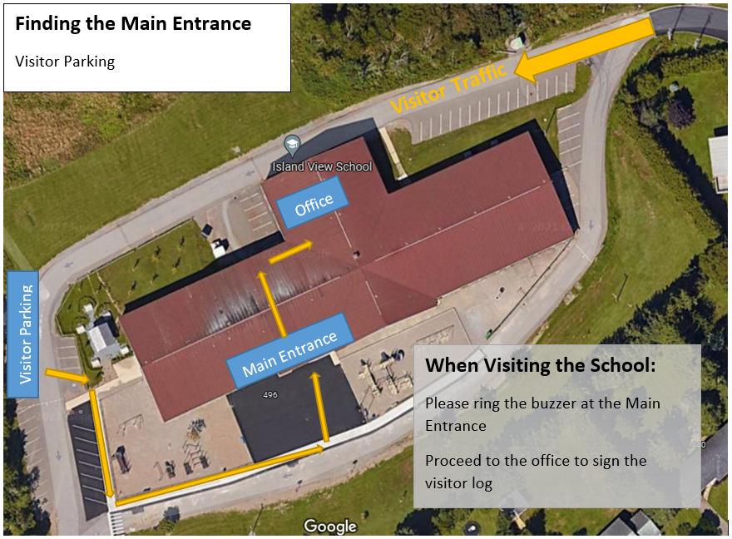
A

B

Parent School Support Committee (PSSC)
Our Parent School Support Committee (PSSC) meet four to five times a year at the school. Meetings are open to the public. The PSSC provides valuable input into educational issues facing the school as well as playing a key role in the formation of our School Improvement Plan. Parents are encouraged to volunteer to serve on this committee.

Home and School
The Island View Home and School Association was established in 1989. The goal of the association is to foster a positive partnership between parents and teachers resulting in a positive learning experience for our children. The association consists of four members of the executive team who are elected on an annual basis combined with annually appointed members at large. The remaining members are part of the general membership. Regular monthly meetings are open to all parents.
The IVS Home and School has funded many projects including: purchasing playground equipment, classroom sound systems, books, iPads, and donating to the playground improvements. They also plan with the school to host events such as Fun day and Santa’s workshop. Please consider volunteering your time to support the programs offered by this worthwhile group. You can find them on Facebook under “Island View School – Home & School”.

Class Participation
There are opportunities throughout the school year to volunteer with your child’s class. There may be field trips or class activities where parents are invited to attend to help run the event. Please contact your child’s teacher if you are interested in volunteering.
Please note: Do not take/post photos of other students while on field trips/volunteering since some families have asked that their child not be included in photos.

Parent Responsibilities
As stated in the NB Education Act, the role of the parent is as follows:
A parent, in support of the learning success of their child and the learning environment at the school, is expected to:
- communicate reasonably with school personnel employed at the school their child attends as required in the best interests of the child and the school community,
- cause their child to attend school as required by this Act,
- ensure the basic needs of their child are met, and
- have due care for the conduct of their child at school and while on the way to and from school.
- encourage their child to attend to assigned schoolwork and/or homework.

Positive Learning Environment

Behaviour Standards
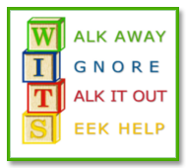
The code of conduct as Island View School is “Be Respectful, Be Responsible, and Be Safe.” Throughout the year, classes discuss appropriate and expected behaviours in all areas of our school life. These behaviour expectations are posted around the school and reinforced staff (see below).
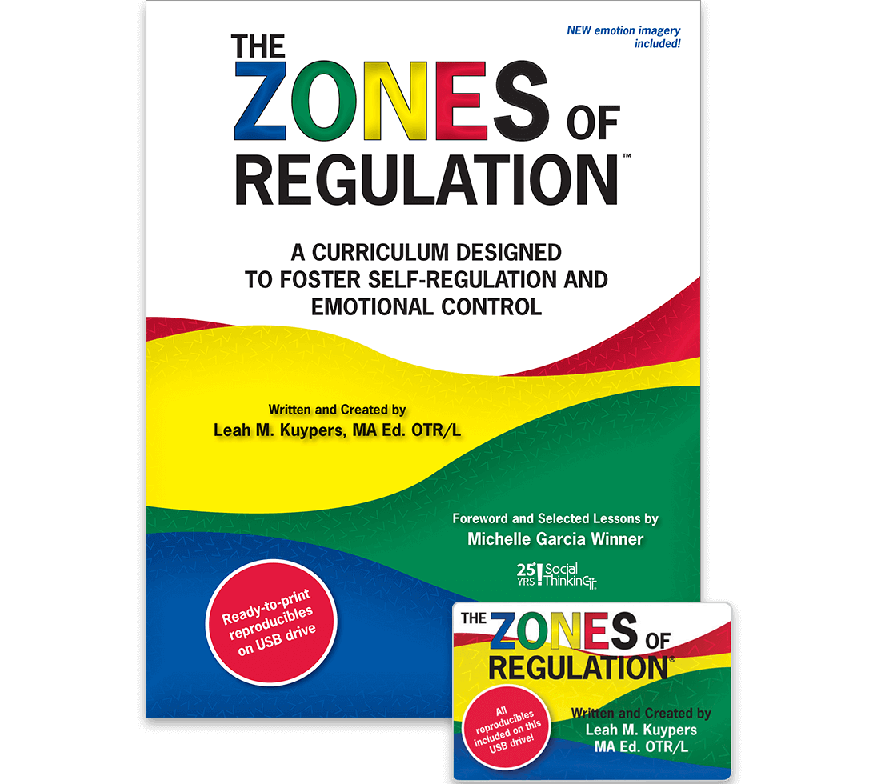
The WITS Program is implemented at Island View School to provide students with the initial steps for dealing with conflict.
The Zones of Regulation is a program that is implemented in all classrooms at Island View School. The program is co-taught with the Guidance Counselor and the classroom teacher, and the language and concepts provide the tools for students to learn about self-regulation.
Island View School Behavior Expectations
 | Be  Safe  To protect yourself and others from harm | Be  Respectful  A positive way of treating someone, something, or a common space | Be  Responsible  It is your job to complete or take care of
Classroom | - Cover your mouth to cough or sneeze  - Use classroom materials appropriately  - Ask permission to leave the class  - Keep it tidy | - Use your manners, “Please, Thank you, Good Morning, Goodbye”  - Respect others personal space  - Ask permission to use others belongings | - Follow classroom expectations  - Participate  - Whole body listening  - Work and allow others to do their work
Bathroom | - Wash hands properly  - Keep hands and feet to yourself  - Walk | - Quickly & Quietly  - Keep your eyes to yourself  - Leave the stall door unlocked after use | - Flush toilet after use  - Clean up after yourself  - Paper towels in the waste basket
Coatroom | - Keeps hands and feet to yourself  - Keep floor clean and clear of clothing and shoes | - Quickly & quietly  - Change in the hallway or class as directed by your teacher | - Hang personal belongings  - Put shoes in their place  - Come into class on time
Hallway | - Keeps hands and feet to yourself  - Face forward  - Walk single file | - Quickly & quietly  - Use manners  - Keep to the right | - Listen to adult directions  - Complete your task
Outside | - Keep hands and feet to yourself  - Rocks, sticks, & snow stay on the ground  - Stay within assigned play area  - Ask permission to go inside | - Use manners  - Play fair and take turns  - Follow the agreed upon game rules  - Be mindful of others’ play space | - Listen to adult directions  - Return equipment to its place  - Use your strategies to solve conflict (WITS, Peace Place)

Student Attendance
Student attendance plays an important role in the success a student will achieve with their academic endeavors and their interpersonal relationships. When a student begins to accumulate days missed at school, the teacher or other school staff will reach out to families to see if there is a need for extra support. The district attendance protocol for ASDS schools is as follows:
- 5 days missed – Homeroom Teacher contacts family
- 10 days missed – Principal contacts family with a letter and/or phone call.
- 15 days missed – Principal contacts family with a letter, followed by a meeting.
However, please do not send your child to school when they are ill. Children should stay home after incidents of fever, vomiting, or diarrhea. Students should be fever-free for 24 hours without using fever-reducing medications, free from vomiting and/or diarrhea for 48 hours, and well enough to attend school, before they return to school. We understand that children get sick, and these absences are unavoidable.
For further information on how to respond to illness with your child, please visit School Exclusion Guidelines for New Brunswick at https://www2.gnb.ca/content/dam/gnb/Departments/h-s/pdf/en/CDC/HealthProfessionals/SchoolExclusionGuidelines.pdf

Medical Information
It is important families notify the school of any medical concerns associated with their child for us to include in the Medical Alert File, which profiles all students who have special medical needs (asthma, severe allergies, etc.). This ensures that we are aware of procedures to be followed should an emergency occur. Parents are expected to complete the medical forms sent home at the beginning of the school year and return them promptly to your child’s teacher.

ASD-S IS A NUT FREE SCHOOL DISTRICT AND FOODS CONTAINING NUTS ARE NOT TO BE SENT TO SCHOOL. PLEASE READ CAREFULLY OUR DETAILED POLICY STATEMENT WHICH IS SENT HOME AT THE BEGINNING OF THE SCHOOL YEAR.
Due to the severity and increase with allergies in school aged children, we ask families to speak with their children about the importance of proper hand washing and not sharing foods with classmates. If you are unsure about food items, please discuss with your child’s teacher well in advance to ensure it is a safe and inclusive product. We appreciate your cooperation in creating a safe school for our students.
Sunscreen, deodorant, hand cream, and hand sanitizer used at school must be unscented. No aerosol sprays are permitted.
Head Lice: It is inevitable that cases of head lice or nits will occur throughout the school year. You should check your child’s head on a regular basis to help keep infestation in the school to a minimum. Should lice be detected at school, the infected child’s parent will be contacted to ensure they receive immediate treatment. Upon their return to school, a staff member will check to ensure treatments have taken place. Please discuss with your child the importance of not sharing hats, brushes, hair clips, etc. to help prevent the spread. Other tips: tuck hats into jacket sleeve and add tea tree or peppermint oil to conditioner.

